Manage user permissions

Manage roles of users

Manage Social Network report

Manage Q/A details

Manage shares details

Manage posts details

Manage followers details

Manage user details

Admin

Admin

Manage system Admin

**Level 2 DFD (PART-2)**

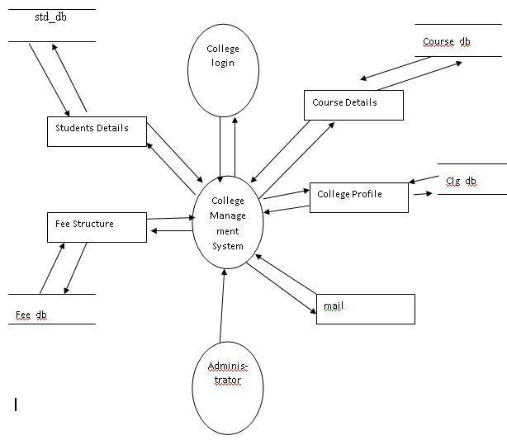

**Level 1 DFD**

**College Application Approval**

Fee Structure

College Profile

Course Details

Students Details

Stud_ID Course_ID

Details Course_Details

Stud_ID Fee_Details College_ID College_Details

S tud_ID Student_mail

**Level 0 DFD**

**College Application Approval**

Mail